KJSCE/IT/TY B Tech/SEMVI/SM/2021-22

**Experiment No. : 4**

**Title: Single channel Queuing system using**

**spreadsheet (The Grocery Store problem)**

**(Autonomous College Affiliated to University of Mumbai)**

KJSCE/IT/TY B Tech/SEMVI/SM/2021-22

**Batch:A4** **Roll No.:1914078** **Experiment No.:4**

**Aim:** To simulate Single Channel Queuing System

**Resources needed:** Microsoft Excel / Open Office

**Problem Statement:**

A small grocery store has only one checkout counter. Customers arrive at this checkout counter at random.

In order to evaluate the system performance

|  |  |  |  |  |  |  |  |  |  |
| --- | --- | --- | --- | --- | --- | --- | --- | --- | --- |
| a) | | Let the arrivals be uniformly distributed between 1 to 8 minutes. | | | | | |  |  |
| b) | | Let service time distribution | | be as per the following | | probability distribution: | | |  |
|  | Service | | 1 | 2 | 3 |  | 4 | 5 | 6 |
|  | Time(minutes) | |  |  |  |  |  |  |  |
|  |  | |  |  |  |  |  |  |  |
|  | Probability | | 0.05 | 0.1 | 0.2 |  | 0.3 | 0.25 | 0.1 |



c) Perform simulation for 20 customers and compute the performance measures.

**Concepts:**

The key elements of queuing system are customers & servers. The term customer can refer to people, machines, and trucks. The server might refer to receptionist, person etc.

A queuing system is described by its calling population, the nature of the arrivals, the service mechanism, the system capacity and the queuing discipline.

|  |  |  |  |  |  |
| --- | --- | --- | --- | --- | --- |
| **1. Calling population**: The population | of potential | customer is referred to | | as | calling population. |
| In systems with large population the calling population is | | | usually assumed | to | be infinity. E.g. |
| population of potential customer of a | bank. The | actual | population may | be | finite. The main |

difference between finite & infinite population is based on the definition of the arrival rate.

1. **System Capacity**: The system capacity has no limit meaning that any no. of units comes

and waits in the queue. In many queuing system there is a limit to the no. of customers that may be waiting.

1. **Nature of Arrivals**: Arrivals for service occur at a time in random fashion and once they join the waiting line, they are served.
2. **Service Mechanism:** The units are served in order of their arrival by a single server or a channel.
3. **Queuing Discipline:** It refers to the logical ordering of customers that will be chosen for service when a server becomes busy.
4. **State Of System:** It is the no. of units in the system & status of server (busy / idle).

**(Autonomous College Affiliated to University of Mumbai)**

KJSCE/IT/TY B Tech/SEMVI/SM/2021-22

1. **Events:** It is a set of circumstances that causes an instantaneous change in the state of system

Possible events in a single server system: • The Entry of a unit in the system.

• Departure of unit from system on completion of service.

1. **Simulation Clock**: It is used to track simulation time.

**Conceptual Model:**

The grocery store with one checkout counter is simulated by using a Semi – automatic approach by using simulation table to record successive system snapshots as time advances. The simulation requires mainly a service time distribution and an interarrival time distribution of customers.

**Characteristics of Grocery Store checkout counter System:**

1. Calling Population: Infinite.
2. System capacity: Infinite.
3. Nature of Arrival: Random arrival uniformly distributed.

IV) Service Mechanism: At a time only one customer is served; service time is random, probability distribution is given.



1. Queuing Discipline: FIFO.

**System State:**

1. Waiting time in queue.
2. Status of server (Busy / Idle)
3. Time customer spends in the system.

**Entities:**

The entities in single channel queue are queue & server.

**Events:**

1. Arrival Event
2. Departure Event

**Activities:**

1. Interarrival time.
2. Service time.

**Delay:**

Waiting time in the queue.

**Use of Random Nos.:**

* For generating interarrival time
* For generating service time

**Real life Examples**:

1. Customers queuing in the Telephone Bill Payment System Customers form single channel queue. Customer is chosen in FIFO manner.

**(Autonomous College Affiliated to University of Mumbai)**

KJSCE/IT/TY B Tech/SEMVI/SM/2021-22

**Performance measures:**

**1. Average Waiting Time** = (Total time customers wait in queue) / (Total no. of Customers)

**2. Probability of Customers waiting** =(No. of Customers who waits) / (Total no. of Customers)

1. **Probability of Idle Server** = (Total Idle Time Of Server) / (Total runtime of simulation)
2. **Average Time between Arrival** = (Total Time between arrivals) / (No. of arrivals)-1
3. **Average Waiting Time of Those Who Wait** = (Total Time Customer waits in queue) / (Total no. of Customers who wait)
4. **Average Time Customers Spends in System** = (Total Time Customer spends in system) / (Total no. of Customers).

**Activity Diagram:**

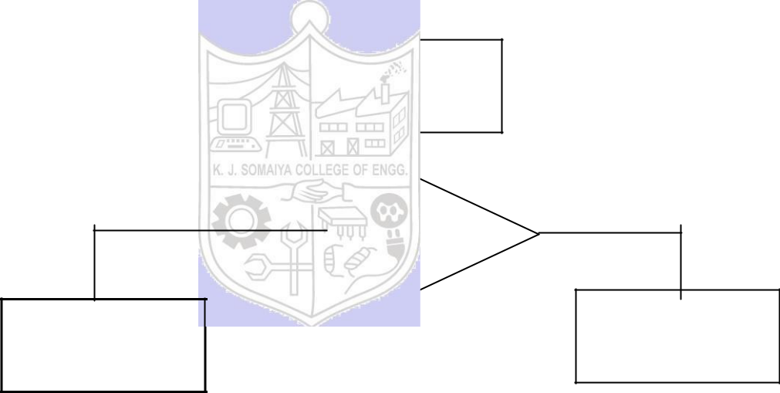

**1)** **Flowchart Arrival event:**

Arrival Event

**NO**

Server Busy?

Enters service

**2)** **Flowchart Departure event:**

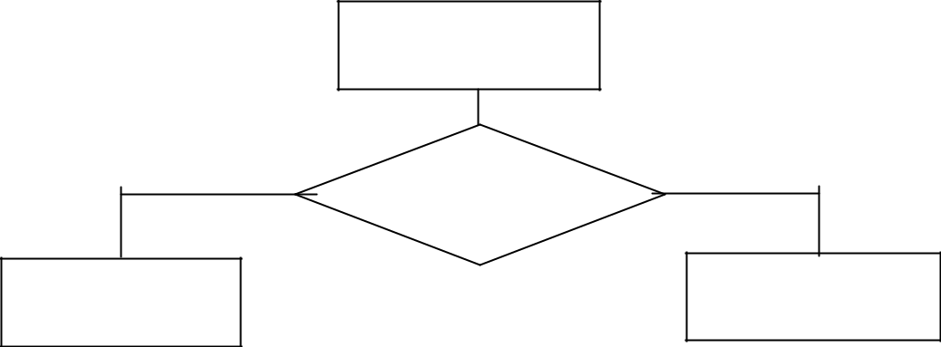

Departure Event

**NO**

Another unit waiting?**YES**

Begin Server Idle

time

**YES**

Unit Enters

queue

Remove waiting

unit from queue

**(Autonomous College Affiliated to University of Mumbai)**

KJSCE/IT/TY B Tech/SEMVI/SM/2021-22

**Results: (Program printout as per the format)**

**Program:**

|  |  |  |  |  |
| --- | --- | --- | --- | --- |
| Arrival Time probabilites | | | | |
| Inter arrival time | Prob | Cd Prob | Range start | Range End |
| 1 | 0.125 | 0.125 | 1 | 125 |
| 2 | 0.125 | 0.25 | 126 | 250 |
| 3 | 0.125 | 0.375 | 251 | 375 |
| 4 | 0.125 | 0.5 | 376 | 500 |
| 5 | 0.125 | 0.625 | 501 | 625 |
| 6 | 0.125 | 0.75 | 626 | 750 |
| 7 | 0.125 | 0.875 | 751 | 875 |
| 8 | 0.125 | 1 | 876 | 1000 |

|  |  |  |  |  |
| --- | --- | --- | --- | --- |
| Service time probabilites | | | | |
| Service time | Prob | Cd Prob | Range start | Range End |
| 1 | 0.05 | 0.05 | 1 | 5 |
| 2 | 0.1 | 0.15 | 6 | 15 |
| 3 | 0.2 | 0.35 | 16 | 35 |
| 4 | 0.3 | 0.65 | 36 | 65 |
| 5 | 0.25 | 0.9 | 66 | 90 |
| 6 | 0.1 | 1 | 91 | 100 |

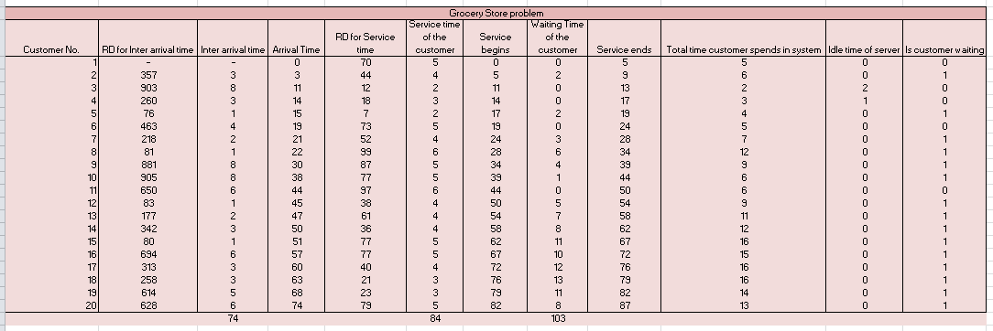

**Macro for assigning random numbers**

Sub Update_Table()

For i = 17 To 35

Range("B" & i).Value = WorksheetFunction.RandBetween(1, 1000)

Next i

For i = 16 To 35

Range("E" & i).Value = WorksheetFunction.RandBetween(1, 100)

Next i

End Sub

**Output**:

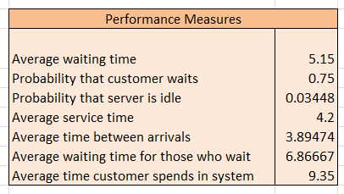

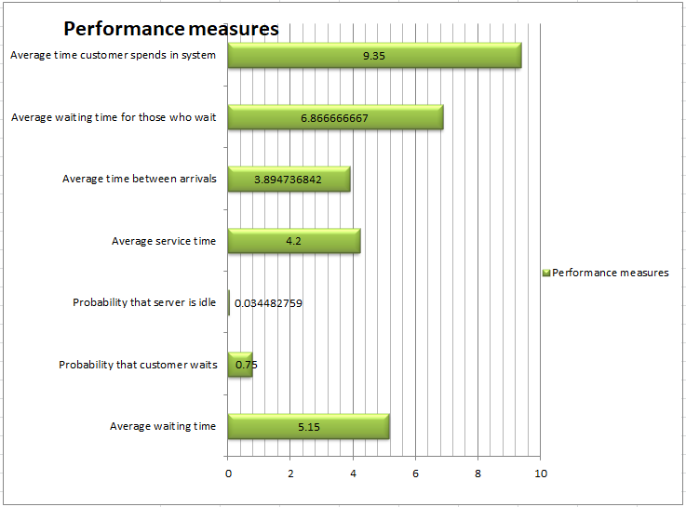

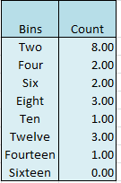

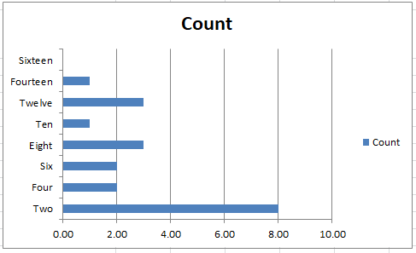

**Questions:**

1) What is simulation? List down the different types of simulation.



* Simulation is the imitation of the operation of a real-world process or system over time to develop a set of assumptions of mathematical, logical, and symbolic relationship between the entities of interest, of the system to estimate the measures of performance of the system with the simulation-generated data
  1. Interpret the flow diagrams for the two events given above.
* There are 2 events that happen in the system:
  + A customer arrives
  + And a customer leaves
* On arrival,
  + If there’s no queue at the counter, the customer doesn’t have to wait and can go to the service counter.
  + Else, the customer enters the queue until service counter is free and there’s no one ahead of him in the queue.
* On departure,
  + If there’s a queue, the next customer comes to the service counter
  + Else, the server becomes idle.

1. What is an exogenous event? What is an endogenous event? Give an example for each.

* Exogenous event is a term used to describe events occurring outside the system, in the environment. A simple example is natural disasters/
* Endogenous events are events that occur inside the system. Departure of customers is an endogenous event.

**Outcomes:**

We applied the experimental process of simulation for model building using simulation  
languages and tools

**Conclusion:**



Simulated a Single channel Queuing system in the Grocery store problem using spreadsheet in MS Excel 2007.

**Grade: AA / AB / BB / BC / CC / CD /DD**

**(Autonomous College Affiliated to University of Mumbai)**

KJSCE/IT/TY B Tech/SEMVI/SM/2021-22

**Signature of faculty in-charge with date**

**References:**

**Books/ Journals/ Websites:**

1. Jerry Banks, John Carson, Barry Nelson, and David M. Nicol; “Discrete Event System Simulation”, Fifth Edition, Pearson Education.

1. Jerry Banks, John Carson, Barry Nelson, and David M. Nicol; “Discrete Event System

Simulation”, Third Edition, Pearson Education.

3. Queuing Tutor [:http://www.dcs.ed.ac.uk/home/jeh/Simjava/queueing/mm1](http://www.dcs.ed.ac.uk/home/jeh/Simjava/queuei)_q/mm1_q.html This site has two animated displays of waiting lines. The user can change arrival and service rates to see how performance is affected.

1. Myron Hlynka‟s Queuing Page:http:www2.uwindsor.ca/hlynka/queue.html This web site contains information about waiting lines as well as links to other interesting sites.
2. The Queuing ToolPak is an Excel add-in that allows you to easily compute performance measures fora number of different waiting line models

**(Autonomous College Affiliated to University of Mumbai)**

KJSCE/IT/LY B

Tech/SEMVII/MS/2020-21

**(Autonomous College Affiliated to University of Mumbai)**